OOP LAB 1 TASK 1

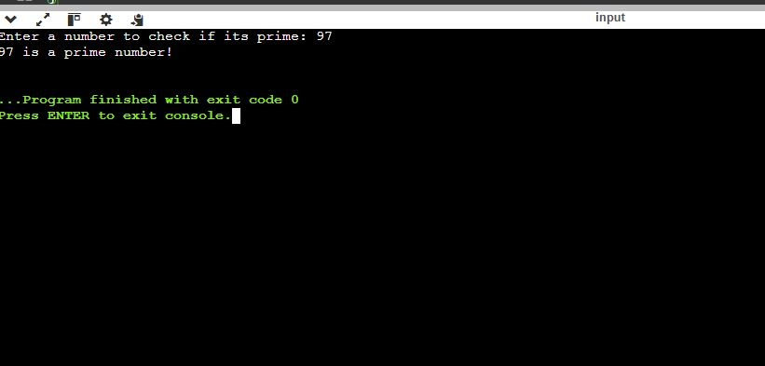

OOP LAB 1 TASK 2

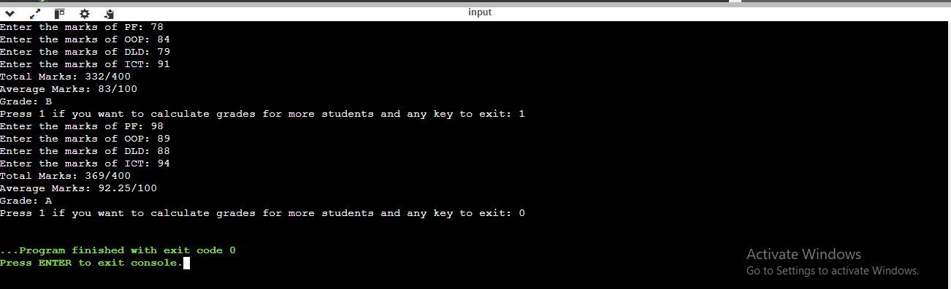

OOP LAB 1 TASK 3

OOP LAB 1 TASK 4

OOP LAB 1 TASK 5

OOP LAB 1 TASK 6

OOP LAB 1 TASK 7

